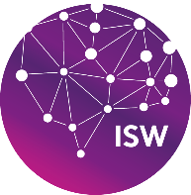

UNIVERSIDAD POLITÉCNICA DE DURANGO

ISW BIS

Professional Internship II

“Centro Ecoturistico Website: Final Report”

Institutional advisor: Prof. Adrián Estefano Rivera Bermúdez

Business advisor: Fernando Soto Melendez

Student’s name: Carlos Eduardo Soto Ramírez

7A

Contenido

INTRODUCTION 1

FRAME OF REFERENCE. 3

GENERAL INFORMATION ABOUT THE COMPANY. 3

CURRENT STATUS. 4

PROBLEM 5

JUSTIFICATION: 5

GENERAL OBJECTIVE. 5

SPECIFIC OBJECTIVES. 6

THEORETICAL FRAMEWORK 6

Best Practices in Web Design 6

User Experience Design and Optimization: What-Why-How 9

Industry stats which prove the importance of UX Design Optimization 9

UX Design and Optimization 10

User experience design principles/rules to making that big move 10

What is SEO? – Search Engine Optimization 11

Why is SEO important? 11

Types of SEO 11

Technical optimization 12

The role of a website in enhancing a company's online presence and expanding its business. 12

Seizing On an Opportunity 13

Building A Stronger Presence 13

PROJECT DEVELOPMENT 13

Planning Phase: 13

1. Define project scope 13

2. Set objectives 14

3. Identify requirements 14

4. Identify the target audience: 14

5. Determine the website's features and functionalities: 14

Design Phase: 15

Development Phase: 18

Testing phase: 20

Deployment phase: 20

CONCLUSION: 20

BIBLIOGRAPHY 21

# INTRODUCTION

Internships are an essential part of the learning process, providing students with the opportunity to apply their knowledge and skills in a real-world setting. The project undertaken for this internship involved designing a website for the ecotourism center, Centro Ecoturístico Vencedores. The objective of the project was to create a website that allows users to learn about the center's activities and facilities and to make reservations for one of the available cabins.

The project involved working in a professional environment and applying the knowledge gained from previous coursework to meet the company's requirements. In addition, the project required acquiring fundamental knowledge of front-end development and UI design to ensure that the website meets the needs of both the company and its users. Throughout the project, the intern was able to develop professional skills and gain practical experience in project development, step-by-step, while meeting the required objectives.

FRAME OF REFERENCE.

Developing a project requires a systematic approach, which includes not only the development of the project itself but also careful attention to organization, work methodology, and documentation. Effective project management involves defining the project scope, creating a schedule of activities, establishing project milestones, identifying potential risks, and ensuring timely delivery of the project. In this context, it was required to apply project management principles to ensure the successful development of the website for Centro Ecoturistico Vencedores. Additionally, I had to consider the specific requirements of the company and its users in terms of website design, functionality, and user experience. The report documents the steps taken by the intern to develop the website and the challenges faced in the process. By applying project management principles and techniques, I was able to successfully deliver a high-quality website that meets the needs of the company and its users.

## GENERAL INFORMATION ABOUT THE COMPANY.

Name of the company: Ejido Vencedores y Anexos

Address: Domicilio conocido. San Dimas, Dgo. México.

Phone Number: (674) 866 2055

Email: ucodefo4@prodigy.net.mx

Located in the Sierra Madre Occidental, northwest of the city of Durango, in the municipality of San Dimas, we started operations in 1940 by installing small portable sawmills. The main productive activities are forestry and livestock. With the objective of providing technical assistance to members in the organization, management, and production of the multi-resources of the areas of their development based on the Forestry Law and its regulation, the Technical Conservation Directorate of the Conservation and Forest Development Unit No.4 was created.

At the moment the ecoturistic center counts with:

* 20 trout grow-out ponds
* 6 ponds for breeding management
* 1 quarantine unit for fry production
* 4 fully equipped cabins
* 1 multipurpose sports court
* 1 office
* 1 warehouse
* Camping area
* Grilling area
* Apple orchards
* Public bathrooms
* Perimeter fence
* Fishing pond
* Deer and bird watching area

## CURRENT STATUS.

Currently, "Centro Ecoturístico Vencedores" has a great potential for ecotourism activities, but it lacks a website that represents them as a company. A website is a crucial tool for any company as it serves as a friendly presentation to users, allowing them to get to know the company and the services it offers. In this case, the website will allow users to learn about the center's activities, cabins, and reserve them.

Although "Centro Ecoturístico Vencedores" has a good reputation in the local community, it is not well-known outside the region due to the lack of online presence. The company currently has no website or social media accounts, which makes it difficult for potential customers or partners to learn about the center's services and facilities.

For these reasons, the goal of the internship project was to create a website that provides detailed information about "Centro Ecoturístico Vencedores" and its services, allowing the company to reach a wider audience and expand its business. The website will showcase the center's cabins, activities, and reservation system, making it easier for users to plan and book their visit.

## PROBLEM

The lack of presence and promotion can hinder the growth and expansion of any company. For the center, this problem is even more pressing due to the lack of photos and videos that can showcase the beautiful location and exciting activities available. "Ejido Vencedores y Anexos" currently does not have a website to promote its services and activities, and while it has a social media presence, it lacks detailed information and visual aids. Without a complete website, the center is missing out on the opportunity to attract more users and expand its business effectively. Plans are already underway to create a website that showcases the center's services, products, and beautiful location, so that potential customers and partners can experience the quality service "Ejido Vencedores y Anexos" offers.

## JUSTIFICATION:

The main objective of "Ejido Vencedores y Anexos" is to provide

satisfactory services to its customers. In order to achieve this objective, it is

important to have a website that is not only visually appealing but also provides

detailed information about the center's activities, facilities, and services offered.

Moreover, a website can act as a promotional tool by displaying photos and videos

of the cabins, activities, and amenities that are available to guests. By having a

website, the center can reach a wider audience and potential customers can make

reservations online, resulting in increased revenue. Standardizing operations and

continuously improving services will not only benefit the customers but also the

company itself, leading to growth and success in the long term.

## GENERAL OBJECTIVE.

The main objective of this project is to design and develop a website for "Ejido Vencedores y Anexos". The website will not only serve as a digital representation of the company, but also showcase its activities and services to the general public. The website will provide a quality service and a pleasant experience to its customers and new users who are interested in learning more about the company. In addition, it will attract future companies who are interested in working together with "Ejido Vencedores y Anexos". By following good practices of web design and development, the website will enhance the company's online presence and increase its chances of expanding its business.

Furthermore, the website will address the current lack of visual promotion of the center, by including photos and videos to showcase the facilities and operations of the company.

### SPECIFIC OBJECTIVES.

1) Have a functional static website that shows what "Ejido Vencedores y Anexos" offers to their visitors.

2) Offering the ability to communicate between users and the company.

3) Show a catalog of the activities that take place in "Ejido Vencedores y Anexos".

4) Make an easy way, user interaction with a website more than clear and directly and easily understand "Ejido Vencedores y Anexos" objectives.

# THEORETICAL FRAMEWORK

Great design goes a long way. The experience visitors have with your website sets the stage for their relationship with your product, your company, and your brand. A coordinated UI/UX design will produce a website that is visually attractive as well as easy to navigate for your users.

So much of website design controls how your brand interacts with prospects and customers. But what if users find your site confusing and can’t find what they are looking for? Consider what happens if visitors don’t want to wait for a page to load on your site. What happens if they can’t locate a call to action such as a link to your contact form or button to download your content offer? Chances are they’ll bail, as the average user attention span is getting shorter and shorter.

User interface (UI) and user experience (UX) design can help you solve these problems. While each has a different focus, they can work together to create the most effective digital design. UI design is essentially concerned with graphics, page layout, and formatting layout while UX design centers around the way users interact with and move through a site. Whether you have a simple “brochure” site, a software-as-a-service platform, or an eCommerce website, using time tested and proven UI/UX design principles are an absolute must for optimizing your site.

## Best Practices in Web Design

1. Keep it simple: Users are more likely to find the key messaging on your website if they have less content to scroll through and fewer options to choose from. Minimizing the options on your site will increase the likelihood that readers will take the action your brand seeks, such as leading them through a sales conversion funnel. Imagine the best grocery store experience where everything along the way is exactly where you need it!

A simpler design also loads faster and reduces the bounce rate from your site.

This also boosts your site’s search engine optimization (SEO).

1. Use consistency: Readers will find it easier to scroll through your site if you use consistency in your design. This applies to your colors, fonts, buttons, layout structure, photograph style, and more. The point is to make these design components familiar to your users, which helps make things more intuitive and predictable.

Beyond the internal consistency, website visitors also like to make connections with design conventions used across the web. The location of navigation buttons, the option to “read more” on content, and the use of autofill on a web form are all common design features across the digital landscape.

All of this consistency takes out the guesswork users may have when trying to interact with your website.

1. Be intentional: Choose the elements of your design with a purpose in mind. The colors, visual elements, and layout you select should all be intentional and not just because they look good. Looks aren’t everything! Design is more about how something works than how it looks. It’s about both form and function.

Here are some guidelines for designing with intent:

* Choose a color because it’s part of the brand identity guide or because it evokes the desired emotion.
* Choose a font because it shows personality and allows the user to more easily read your content.
* Choose a visual element that helps users accomplish a task on the site.
* Choose a layout that showcases the most important parts of your design and that improves site navigation.

1. Set Expectations: Along the lines of using consistency to create predictability, users also want their expectations for browsing your website to be met. They want to understand what will happen if they take an action on your platform. Tell users what the buttons on your website are intended to do. If the button will sign them up for your newsletter, add appropriate text on the button— “Sign Up Now” or “Join Our Email List”—that tells them exactly what will happen if they submit their email address.

Another feature reader will appreciate is an animated loading graphic. These “loaders” will let them know that the page is not frozen if there is a wait time while something loads.

Meeting your users’ expectations requires some design elements that may be obvious. For example, give commonly used names to the headers on the navigation menu. This will reduce any potential frustration readers may have while navigating and becoming familiar with a new platform.

1. Expect the unexpected: Don’t assume that everything will work out as you expected! There will always be exceptions to the rule. If you assume that your target audience is tech-savvy, for example, you’ll likely have someone in the crowd who is not. For users who are not digital natives, make sure the tabs and buttons on your site are clearly marked so that they can easily understand how to navigate through your site. Don’t abandon them to wander the proverbial halls in awkwardness – they’ll probably leave!

If you expect that everyone’s internet connection is fast, you won’t reach users who have low bandwidth and can’t download large images. To avoid this problem, avoid using complex graphics or custom typefaces that not all users will be able to access.

While your analytics may show that your visitors are primarily on desktop computers, don’t rule out the potential mobile device audience. Make sure your site is user-friendly on all devices and not just targeting a specific screen size.

Bonus points: Mobile-friendliness is a critical factor for good search engine optimization as well.

1. A hospitable site is accessible and inclusive: How will users who are colorblind or have a hearing impairment experience your site? Creating a website that is disability-friendly might not be something you “see” right from the start—unless you happen to be someone who needs to navigate the platform using accommodations.

Try using a screen reader, assistive touch, or a colorblind web page filter and you’ll have an entirely different perspective on whether your site is truly accessible. The first step in making your site available to all users is to determine whether your site’s design creates obstacles for users with disabilities.

1. Use responsive design: Mobile usage has surpassed desktop usage and each year its share of online traffic rises. That’s why you need to use a responsive design on your site so that users can easily read and navigate it on any device.

A website design that isn’t mobile responsive may, for example, force users to enlarge the text on the screen to make it legible. Most often, readers who have to adjust the site on their cell phone to work around your non-responsive design will simply give up and leave your site.

Providing a responsive website doesn’t only enhance the user experience. In fact, Google awards higher rankings to sites that are mobile-friendly, which translates into higher traffic on your site. (There’s that SEO, again!) Responsive websites load more quickly, look great on every screen, and are easier to update.

It’s critical to make a positive first impression on users coming to your site from mobile devices. If you don’t, you might lose them to competitors’ more mobile-responsive sites.

1. Plan for the future: While building the website or mobile app that you need now, take into account that your site will likely change in the future. That is why you should create your site on a framework that’s flexible enough to allow you to adapt, change and expand as your business grows.

Choose your tools wisely so that you will not end up with a site with components that cannot be updated. A case in point: Adobe Flash was once a standard software platform that was used for the production of animation, apps, and mobile games. Yet Adobe has announced it will no longer update or maintain Flash after 2020, which means web developers will have to switch to alternate solutions if they haven’t already.

## User Experience Design and Optimization: What-Why-How

### Industry stats which prove the importance of UX Design Optimization

* 68% of users leave a site because of poor User-centered design
* About a whopping 97% sites fail owing to bad UX designs
* You have about 3 seconds for a user to find what they want on your web page before they leave.
* 48% of users say that if they arrive on a business site that isn’t working well on mobile, they take it as an indication of the business simply not caring.
* Only 55% of companies are currently conducting any kind of online testing to optimize user experience.
* 44% of online shoppers tell a friend about a bad online experience.

### UX Design and Optimization

The web has witnessed mammoth advances; however, a website’s success still depends on just one thing: how users interact with it.

Few questions that run through any visitor’s mind as they experience your site and decide whether or not they will return or cruise further are:

– Does this website give me value?

– Is it simple to use?

– Does it navigate me to the right place?

– Am I engaged?

– Is it pleasant to use?

Whether you are aware of these or not, practically UX design is all about convincing them to answer “Yes” to all above questions.

It’s all about keeping your users hooked. Precisely user insights are the most important ingredient to establishing a great design experience for users. For user-perfected experiences, understanding the user’s thoughts and concerns is important.

Fabricating user-centric design involves a wide range of skills that encompass creating personas, wireframes, specifications, information architectures, interaction flows, high-resolution comps, and prototypes; conducting user research, doing usability studies, and organizing content. All this sits within the fuzzy boundaries of UX design principles.

### User experience design principles/rules to making that big move

* It has to be natural & intuitive.
* He should never ever have to stop to think how to do something.
* Operation must be consistent throughout to ensure a great user experience.
* UX design is an idea to improve the lives of users and customer life-cycle.
* Optimizing User experience is a process of discovery, vision definition, strategy, planning, execution, measurement and iteration.
* Creating rich experience for user, is not only about the design, it is more about influence.
* Empower and respect your users. Happy users who experience helpful interactions that guide them through your products/services.
* By following principles like creation of working prototypes, scientifically measurable UX results can be achieved.

## What is SEO? – Search Engine Optimization

SEO stands for “search engine optimization.” In simple terms, SEO means the process of improving your website to increase its visibility in Google, Microsoft Bing, and other search engines whenever people search for:

* Products you sell.
* Services you provide.
* Information on topics in which you have deep expertise and/or experience.

The better visibility your pages have in search results, the more likely you are to be found and clicked on. Ultimately, the goal of search engine optimization is to help attract website visitors who will become customers, clients or an audience that keeps coming back.

### Why is SEO important?

SEO is a critical marketing channel. First, and foremost: organic search delivers 53% of all website traffic.

That’s one big reason why the global SEO industry is forecast to reach a staggering $122.11 billion by 2028. SEO drives real business results for brands, businesses and organizations of all sizes.

Whenever people want to go somewhere, do something, find information, research or buy a product/service – their journey typically begins with a search.

### Types of SEO

There are three types of SEO:

* **Technical SEO**: Optimizing the technical aspects of a website.
* **On-site SEO**: Optimizing the content on a website for users and search engines.
* **Off-site SEO**: Creating brand assets (e.g., ​​people, marks, values, vision, slogans, catchphrases, colors) and doing things that will ultimately enhance brand awareness and recognition (i.e., demonstrating and growing its expertise, authority and trustworthiness) and demand generation.

### Technical optimization

Optimizing the technical elements of a website is crucial and fundamental for SEO success.

You want to make it easy for search engines to discover and access all of the content on your pages (i.e., text, images, videos). What technical elements matter here: URL structure, navigation, internal linking, and more. Experience is also a critical element of technical optimization. Search engines stress the importance of pages that load quickly and provide a good user experience. Elements such as Core Web Vitals, mobile-friendliness and usability, HTTPS, and avoiding intrusive interstitials all matter in technical SEO.

Another area of technical optimization is structured data (a.k.a., schema). Adding this code to your website can help search engines better understand your content and enhance your appearance in the search results.

## 

## The role of a website in enhancing a company's online presence and expanding its business.

A thriving business feeds on generating engagement. During this time of uncertainty, it is absolutely crucial for businesses to connect with consumers and stay relevant. In the last decade or so in particular, many consumers have become accustomed to finding what they want online. According to a Salesforce survey, 85% of consumers conduct research before they make a purchase online, and among the most used channels for research are websites (74%) and social media (38%). Consequently, businesses need to have an effective online strategy to increase brand awareness and grow.

A digital presence gives your brand an ideal platform to communicate with consumers. It gives you the opportunity to set the narrative on who you are as a brand and set yourself apart from competitors. More than just your website, your digital presence expands to all the touch points a consumer may have with your brand online. While this does indeed include your website, it can also include areas outside of your control, such as the conversations about your brand on social media and online reviews. In order to put your best foot forward in front of consumers, consider bolstering all aspects of your brand online.

### Seizing On an Opportunity

The fact is that regardless of your digital standing, your customers are online. In 2019 alone, there were approximately 3.8 million Google searches conducted each minute, many of which were carried out to find information on local businesses. As you can see from this data, the internet can be a valuable tool for businesses; it provides an opportunity to broaden your reach and communicate with consumers on a global scale. Your website, social media and other digital mediums give you a platform to both educate consumers about your brand and highlight your unique features or values that inspire resonance. Online, consumers can simultaneously learn about who you are as a company and engage with your brand on a more personal level.

Having a substantial digital presence can not only increase consumer awareness, but it can also work to strengthen your brand by building up your credibility. Since consumers are likely to research your brand before making any monetary commitments, they will naturally expect to find your business when they search online. It follows then that your brand should appear (and rank highly) within search results. If consumers can’t find your brand when they search for you, they may question your reliability and even the legitimacy of your business. Your presence online displays a sense of professionalism that allows you to prove your expertise and stand out against your competitors.

### Building A Stronger Presence

The first and most essential step in boosting your brand’s digital presence is creating a professional, user-friendly website. Your website is an incredible asset that allows consumers to find you and hopefully it inspires them to convert. A clean, modern design can visually connect with consumers by exemplifying your personality and brand voice. Moreover, a site that is intentionally designed for an enhanced user experience can make a powerful first impression on consumers.

# PROJECT DEVELOPMENT

## Planning Phase:

1. Define project scope: The scope of this project is to design and develop a website for Ejido Vencedores y Anexos that will showcase the company's activities, services, and products to the general public. The website will be accessible on desktop and mobile devices and will have a user-friendly interface.
2. Set objectives: The objectives of this project are to increase the company's online presence, attract potential customers, provide a platform for customers to learn about the company, and improve customer satisfaction by providing easy access to information about the company's products and services.
3. Identify requirements:

The website will require the following:

* Home page with a brief introduction to the company and its services
* About Us page with a detailed description of the company and its history
* Products and Services page to showcase the products and services offered by the company
* Contact Us page with a form to submit inquiries and contact details
* Testimonials page to showcase the positive feedback from the customers
* Gallery page to showcase the images and videos of the company's facilities and operations
* Mobile responsive design to ensure the website is accessible on mobile devices
* User-friendly interface to improve the customer experience

1. Identify the target audience: The target audience for the website includes potential customers, existing customers, and partners. The website should provide information to educate and attract potential customers, while also providing easy access to information for existing customers and partners.
2. Determine the website's features and functionalities: The website should have a user-friendly interface, easy navigation, quick loading time, and search engine optimization. It should also have a content management system (CMS) for easy updates and maintenance. The website should be designed to meet the needs of the target audience and provide a positive user experience.

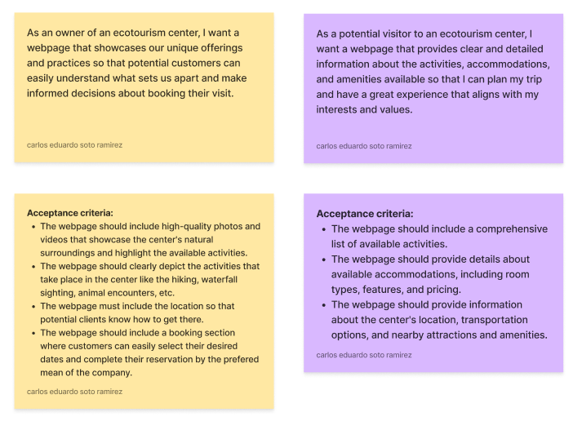

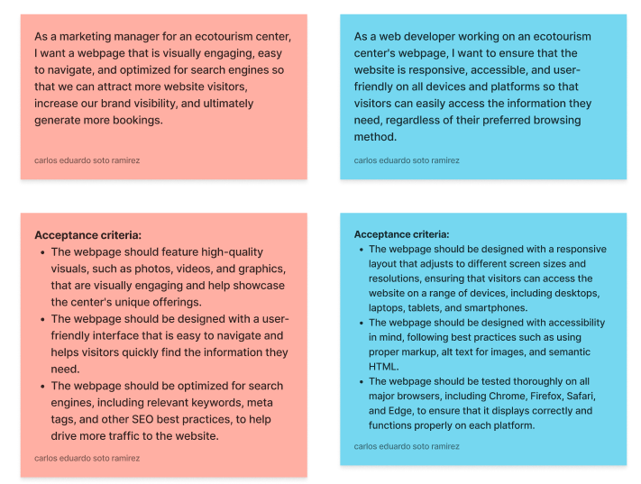

## Design Phase:

In the design phase, Icreated wireframes, mockups, and prototypes to give an idea of how the website will look and function. I began by sketching rough ideas on paper and then moved onto digital wireframes using software like Figma. Once a basic wireframe is in place, I created more detailed mockups using the company's branding guidelines, color scheme, and typography.

I also used mockups to test different layouts and features, ensuring that the website was user-friendly and met the needs of the target audience. I made changes based on feedback from stakeholders and users, tweaking the design until it was just right.

In the end, the design phase resulted in a set of high-fidelity mockups that accurately depicted the final website design. These mockups were used to guide the development phase and ensure that the end product matched the team's vision.

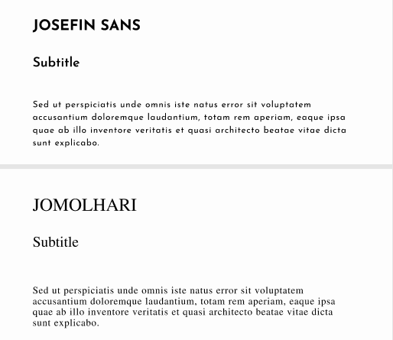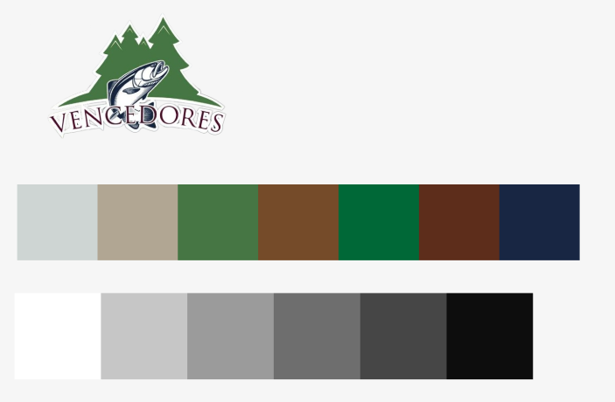

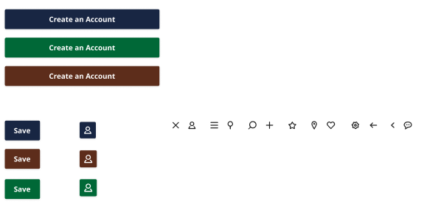

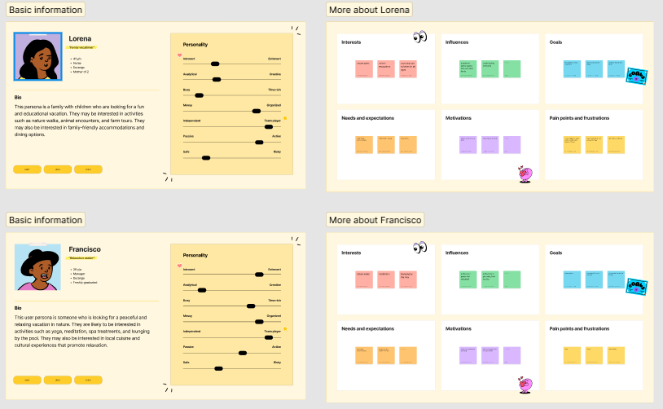

User personas

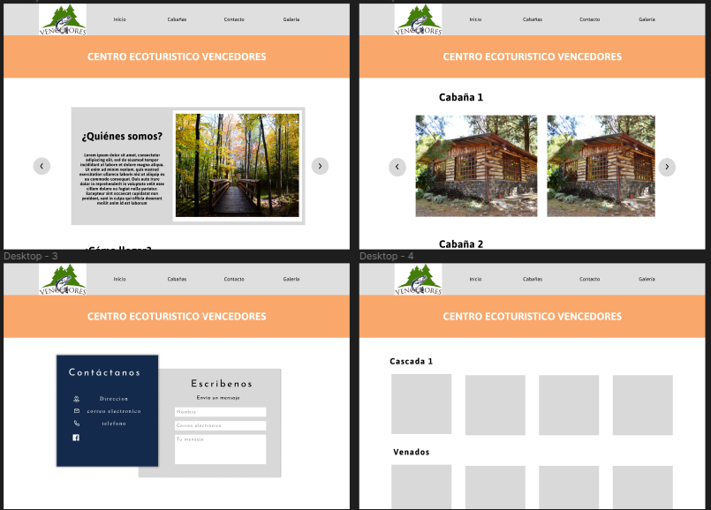

Mockups

Link of the mockups:

<https://www.figma.com/file/mXs33iFg5tOMt9QiLorUj4/Centro-Ecotur%C3%ADstico?node-id=0-1&t=bMU3vY5nDyIeNskl-0>

Link of the design elements (color palettes, user stories, user personas, etc.):

<https://www.figma.com/file/ejb6gy2bmdngL0gYPRd6sm/Planning-phase?t=bMU3vY5nDyIeNskl-0>

## Development Phase:

During the development phase, the website was built using HTML, CSS, JavaScript, and bootstrap. Following the best practices in web development, such as using semantic HTML, optimizing images and other media, and implementing responsive design to ensure the website looks great on all devices.

To ensure the website is user-friendly and intuitive to navigate, the team implemented various features and functionalities, such as a search bar, dropdown menus, and contact forms. They also integrated social media sharing buttons, allowing users to easily share content from the website on their own social media profiles.

In addition, the team conducted thorough testing of the website, using various tools and techniques to identify and fix any bugs or issues. They also ensured the website is optimized for search engines by implementing proper metadata, using descriptive and relevant page titles and headings, and optimizing the website's loading speed.

Overall, the development phase was focused on creating a high-quality, user-friendly website that effectively showcases the services and activities of Ejido Vencedores y Anexos, while also providing a positive user experience for visitors.

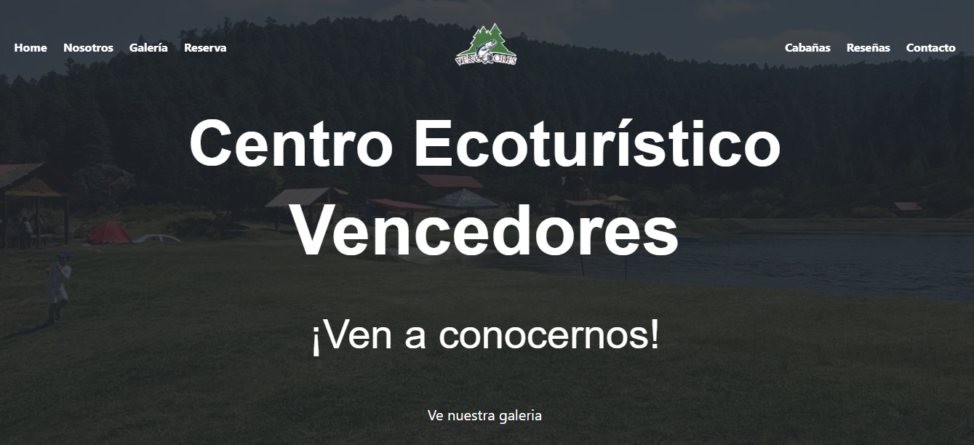

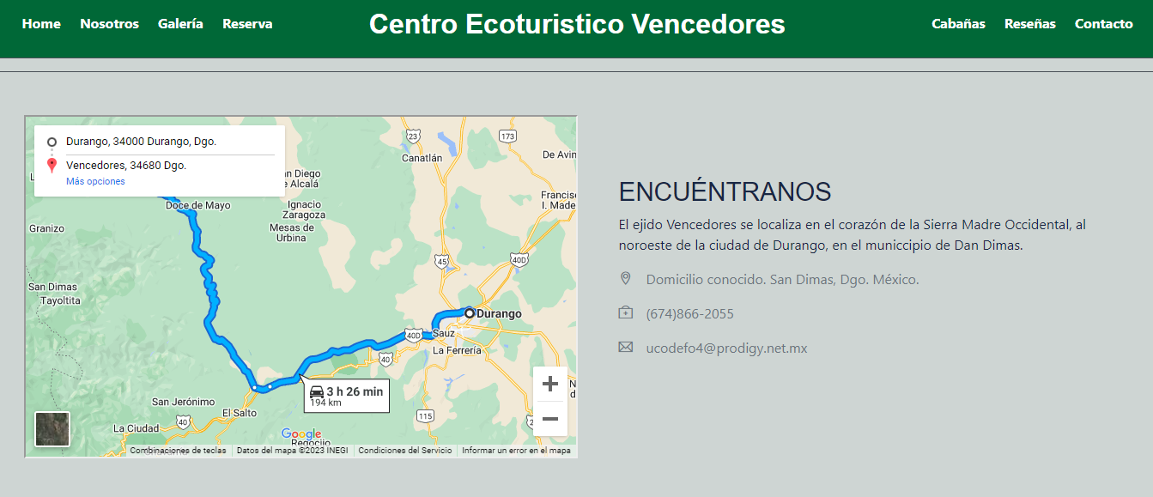

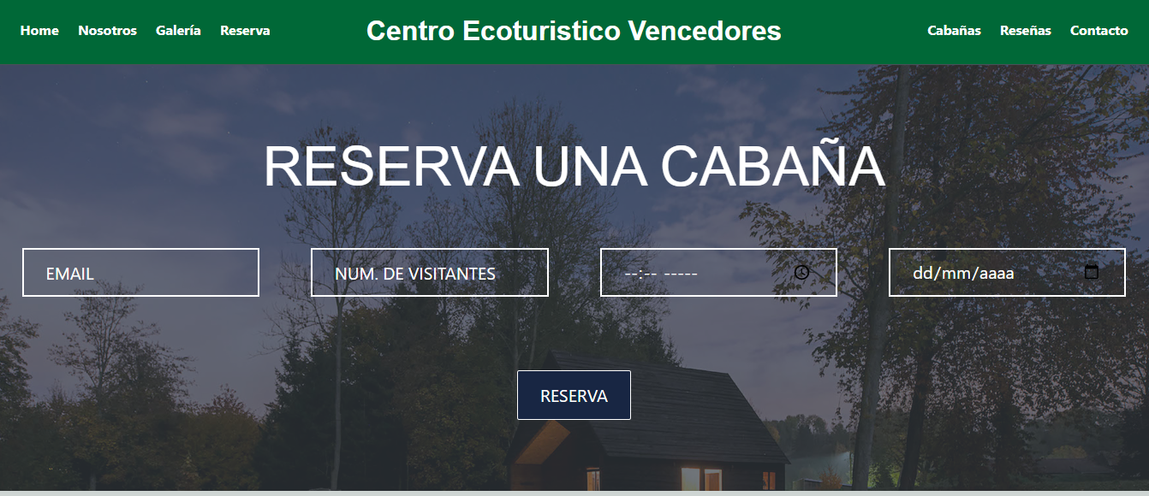

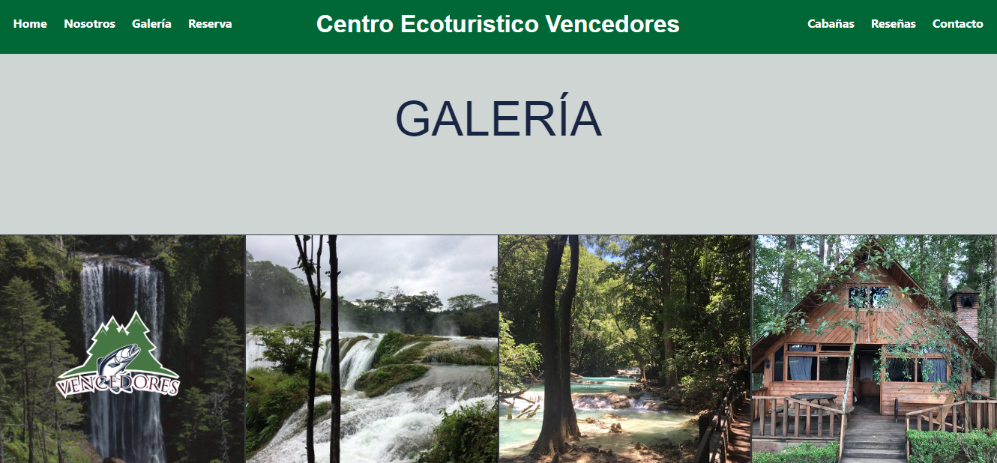

## Testing phase:

Once the website was developed, it underwent a thorough testing process to ensure that it met the requirements and standards established in the planning phase. Testing was done in collaboration with the consultants, who provided valuable feedback and suggestions for improvement. After each testing iteration, the website was refined and adjusted accordingly until it met all requirements and was deemed ready for launch.

## Deployment phase:

After completing the development and testing phases, the website was ready to be deployed to a web server. The web server was selected based on factors such as reliability, security, and cost. Once the server was set up, the website files were uploaded and configured. The website was then tested on the server to ensure that all features and functionalities were working properly. After the testing was completed, the website was made accessible to the public by configuring the domain name and DNS settings. Users could then access the website by entering the URL in their web browser.

# CONCLUSION:

In conclusion, the development of a website for Ejido Vencedores y Anexos has been a successful project that achieved its objectives. Through the planning phase, we defined the project scope, objectives, and requirements, and identified the target audience and website features. The design phase allowed us to create wireframes, mockups, and prototypes that gave us a clear idea of how the website would look and function. In the development phase, we built the website using HTML, CSS, and JavaScript, and implemented the features and functionalities identified in the planning phase.

The testing phase was crucial in ensuring the website's functionality, as we tested it extensively after meeting with the consultants to gather feedback. Finally, the deployment phase allowed us to launch the website and make it accessible to the public.

Overall, the website is a successful representation of Ejido Vencedores y Anexos and its activities, providing a quality service and a pleasant experience to its customers and new users interested in learning more about the company. The inclusion of photos and videos showcased the facilities and operations of the company, addressing the previous lack of visual promotion. We are confident that the website will enhance the company's online presence and increase its chances of expanding its business.

# BIBLIOGRAPHY

*27 UI/UX Design Principles And Best Practices*. (2021). 729solutions. Recuperado 5 de abril de 2023, de <https://729solutions.com/ux-ui-best-practices/>

*User Experience Design and Optimization: What-Why-How*. (2020b, agosto 24). FATbit Blog. <https://www.fatbit.com/fab/user-experience-design-and-optimization-what-why-how/>

Search Engine Land. (2023, 8 febrero). *What Is SEO – Search Engine Optimization?* <https://searchengineland.com/guide/what-is-seo>

Paun, G. (2020, 2 julio). *Building A Brand: Why A Strong Digital Presence Matters*. Forbes. <https://www.forbes.com/sites/forbesagencycouncil/2020/07/02/building-a-brand-why-a-strong-digital-presence-matters/?sh=2cbe267e49f2>